Automated System For Material Return From Customer

## A PROJECT REPORT

***Submitted by,***

# C Bharath Kumar - 20191ECM0008 R Sravan Kumar - 20201ECI0014

**E Sudheer Kumar Reddy - 20201ECI0017**

# Y Kumar - 20201ECI0013

***Under the guidance of***

# Mr. SHEIK JAMIL AHMED,

Assistant Professor, School of CSE

***in partial fulfillment for the award of the degree of***

# BACHELOR OF TECHNOLOGY

## IN

**ELECTRONICS AND COMPUTER ENGINEERING [IT INFRASTRUCTURE]**

**At**



# PRESIDENCY UNIVERSITY BENGALURU JANUARY 2024

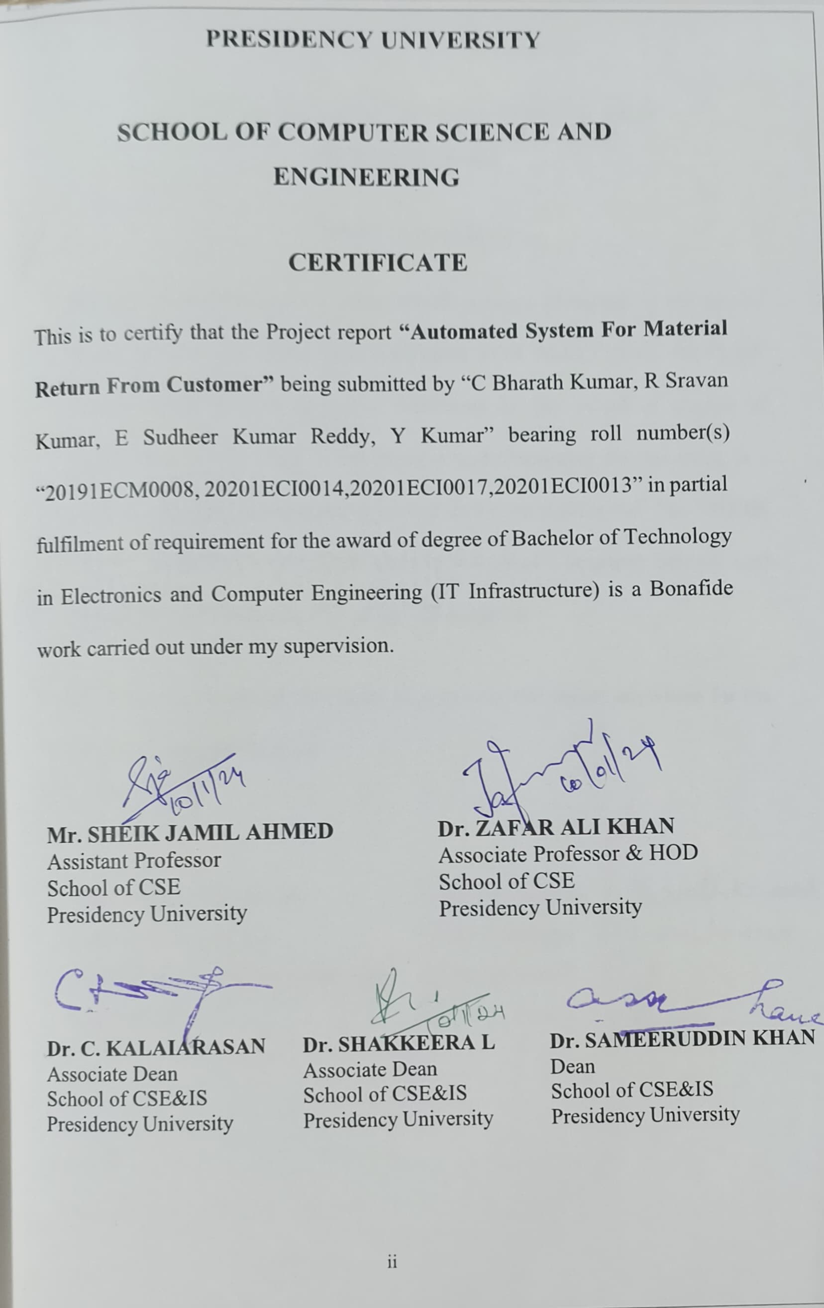

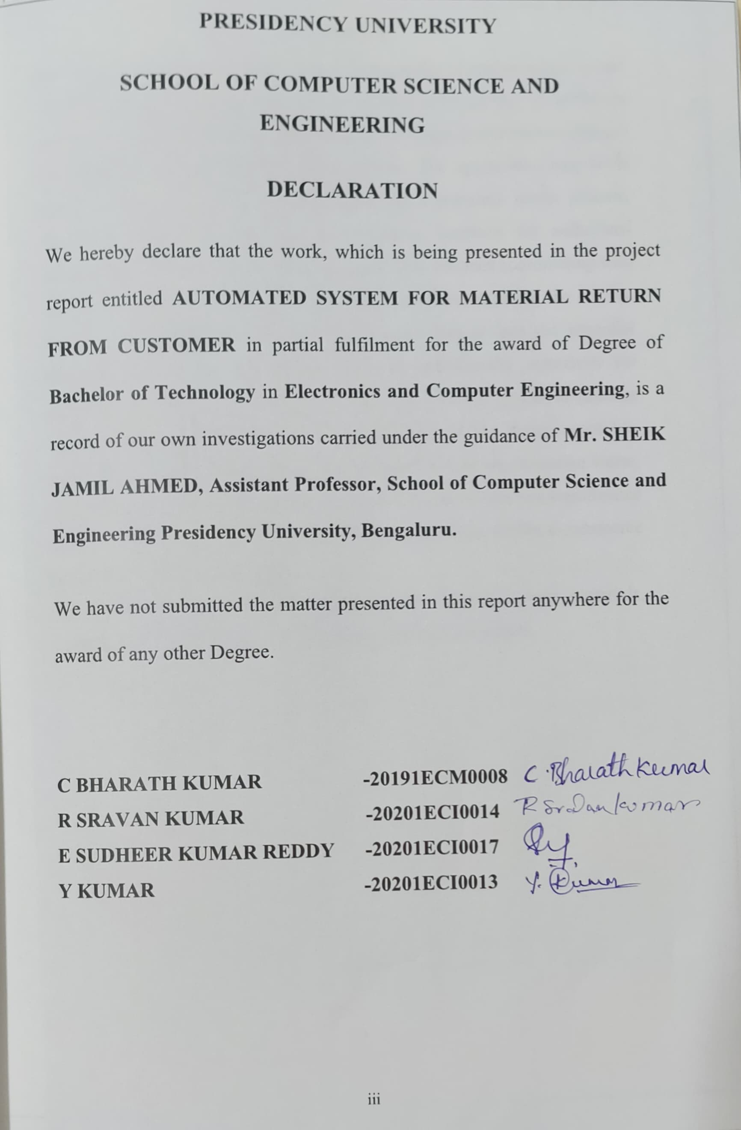

Efficiently managing returned materials in the realm of online orders is vital for both customer satisfaction and environmental sustainability. This abstract centers on a specialized application designed to streamline the return process for materials received through online orders. The application empowers customers to easily request returns, initiating a seamless return process. Simultaneously, it provides an administrative interface for authorized personnel to handle customer return requests. This involves coordinating with delivery personnel, monitoring return shipments, and ensuring the smooth processing of returned materials. The abstract delves into the essential functionalities of the application, such as user-friendly interfaces for customers to add shipments and an integrated tracking system to monitor return progress. By harnessing the capabilities of this return materials application, businesses can elevate their customer service, minimize waste, and optimize resource utilization. The abstract underscores the significance of such applications in promoting sustainable practices within e-commerce and fostering a circular economy.

Keywords: online orders, shipments, return requests, return materials, customers, administrators, users, tracking, delivery personnel.

First of all, we indebted to the **GOD ALMIGHTY** for giving me an opportunity to excel in our efforts to complete this project on time.

We express our sincere thanks to our respected dean **Dr. Md. Sameeruddin Khan**, Dean, School of Computer Science and Engineering and School of Information Science, Presidency University for getting us permission to undergo the project.

We record our heartfelt gratitude to our beloved Associate Deans **Dr. C. Kalaiarasan and Dr. Shakkeera L,** School of Computer Science and Engineering and School of Information Science, Presidency University and HOD **Dr. Zafar Ali Khan,** School of Computer Science and Engineering, Presidency University for rendering timely help for the successful completion of this project.

We are greatly indebted to our guide **Mr. SHEIK JAMIL AHMED, Assistant Professor,** School of Computer Science Engineering Presidency University for His inspirational guidance, valuable suggestions and providing us a chance to express our technical capabilities in every respect for the completion of the project work.

We would like to convey our gratitude and heartfelt thanks to the University Project-II Coordinators **Dr. Sanjeev P Kaulgud, Dr. Mrutyunjaya MS** and also the department Project Coordinators **Dr. Murali Parameswaran.**

We thank our family and friends for the strong support and inspiration they have provided us in bringing out this project.

### C Bharath Kumar R Sravan Kumar

**E Sudheer Kumar Reddy**

### Y Kumar

|  |  |  |  |
| --- | --- | --- | --- |
| **Sl. No.** | **Table Name** | **Table Caption** | **Page No.** |
| 1 | Table 2.1 | Literature Survey | 4 |

2 Table 7.1 Time Line For Execution 12

|  |
| --- |
| Sl. No. Figure Name Caption Page No |
| 1 Figure 4.1 Architecture Diagram 6 |
| 2 Figure 6.1 Sequence Diagram 11 |
| 3 Figure 7.1 Gantt Chart 12 |
| 4 Figure 9.1 Login Page 14 |
| 5 Figure 9.2 Admin Page 14 |
| 6 Figure 9.2.1 Admin Page 15 |
| 7 Figure 9.2.2 Admin Page 15 |
| 8 Figure 9.3 Customer Page 16 |
| 9 Figure 9.3.1 Tracking Page 16 |
| 10 Figure 9.4 Employee Page 17 |
| 11 Figure 9.4 Delivery Page 17 |
| 12 Figure 9.4.1 Delivery Page 18 |
| 13 Figure 9.5 Tracking Page 18 |
| 14 Figure 9.5 Customer Page 19 |
| 15 Figure 9.6 Shipping Details 19 |
| 16 Figure 9.7 Users List (Backend) 20 |
| 17 Figure 9.8 Groups 20 |
| 18 Figure 9.9 Products 21 |
| 19 Figure 9.10 Receipts 21 |
| 20 Figure 9.11 Products (Database) 22 |
| 21 Figure 9.12 Users 22 |
| 22 Figure 9.13 Shipments 23 |
| 23 Figure B.1 Login Page 28 |
| 24 Figure B.2 Admin Page 28 |
| 25 Figure B.3 Employee Page 29 |
| 26 Figure B.4 Delivery Page 29 |
| 27 Figure B.5 Products (Backend) 30 |
| 28 Figure B.6 Products (Database) 30 |

|  |  |  |
| --- | --- | --- |
| **CHAPTER NO.** | **TITLE** | **PAGE NO.** |
|  | **ABSTRACT ACKNOWLEDGMENT**  **…** | **i ii**  **…** |
| **1.** | **INTRODUCTION** | 1-3 |
|  | * 1. Motivation   2. Problem Statement   3. Objective of the project   4. Scope   5. Project Introduction | 1  1  1-2  2  2-3 |
| **2.** | **LITERATURE SURVEY** | **4** |

1. RESEARCH GAPS OF EXISTING METHODS 5
   1. Existing Methodology 5
2. PROPOSED METHODOLOGY 6
   1. Proposed System 6
3. OBJECTIVES 7-8
   1. Functional Requirements 7
   2. Non - Functional Requirements 7-8
4. SYSTEM DESIGN AND IMPLEMENTATION 9-11
   1. Hardware Requirements 9
   2. Software Requirements 9
   3. System Design 9
   4. Implementation 10-11
5. TIMELINE FOR EXECUTION OF PROJECT 12

(GANTT CHART)

1. OUTCOMES 13
2. RESULTS AND DISCUSSIONS 14-23
3. CONCLUSION 24
4. REFERENCES 25

**APPENDIX 26-31**

|  |  |  |
| --- | --- | --- |
| **A** | **PSUEDOCODE** | 26-27 |
| **B** | **SCREENSHOTS** | 28-30 |
| **C** | **ENCLOSURES** | 31 |

# CHAPTER-1 INTRODUCTION

## Motivation

In the contemporary, fast-paced business landscape, implementing an automated system for handling material returns from customers is no longer a luxury but a necessity. The significance of efficient returns management extends beyond just enhancing customer satisfaction; it also plays a pivotal role in reducing operational costs and preventing inventory build-ups. The integration of automated processes enables the swift identification of discrepancies in returns, thereby minimizing potential financial losses. This approach ensures that customers experience timely refunds or exchanges, solidifying their trust in the brand. Furthermore, the data captured through these automated processes empowers businesses to pinpoint recurring product issues, facilitating proactive quality improvements. Embracing this technological advancement is not solely about streamlining return procedures; it's a strategic move aimed at enhancing the overall customer experience and fostering sustainable business growth.

### Problem Statement

In the contemporary e-commerce landscape, businesses encounter significant challenges in effectively handling product returns. Manual systems often contribute to errors, delays, and customer dissatisfaction, compelling companies to explore automated solutions. Present return processes are not only labor-intensive but also lack real-time data analysis, leading to potential losses and inefficient inventory management. This deficiency not only strains resources but also adversely affects brand reputation. There is a market demand for an innovative system that not only streamlines return procedures but also utilizes data for optimizing inventory and elevating the overall customer experience. Bridging this gap is essential for businesses striving to excel in today's competitive e-commerce arena.

## Objective of the Project

The fundamental goal of this project is to develop and implement a cutting-edge automated system that will transform the way material returns are managed in the e-commerce sector. This system seeks to eliminate manual inefficiencies, reduce errors, and streamline the return process to ensure the highest level of customer satisfaction. Through the utilization of real- time data analytics, the solution will offer actionable insights into recurring product issues,

enabling proactive quality checks and efficient inventory adjustments. Through the integration of user-friendly interfaces and robust backend algorithms, the system will seamlessly mesh with existing e-commerce platforms. Ultimately, our project aims to boost brand loyalty, optimize inventory turnover, and substantially reduce operational costs associated with returns management.

### Scope

This project's scope involves designing, developing, and integrating an automated returns management system specifically tailored for e-commerce businesses. This encompasses the creation of a user-friendly interface to facilitate customer-initiated returns, a backend for real- time data analytics, and seamless integration capabilities with existing e-commerce platforms. The system is designed to support various return reasons, enabling efficient categorization and trend analysis. It will also incorporate tools for inventory adjustments and quality feedback loops. While the primary focus is on e-commerce,

## Project Introduction

In the contemporary landscape of online shopping, the success of any e-commerce business hinges significantly on ensuring customer satisfaction. Despite the diligent efforts of retailers and delivery services, instances of customers receiving damaged products do occur. In such situations, the importance of a seamless and efficient return process becomes paramount to preserving customer trust and upholding the business's reputation. The current challenge lies in the absence of a well-structured system that effectively addresses customer concerns when encountering damaged products and seeking replacements or refunds.

The existing deficiency is further exacerbated by the lack of a streamlined communication channel connecting customers, delivery personnel, and the administrative team. This deficiency results in miscommunication, delays, and ultimately, customer dissatisfaction. Moreover, the absence of user management functionalities for the admin and order tracking capabilities for customers contributes to a lack of transparency, To confront these challenges and elevate the overall customer experience, there is an urgent need for a comprehensive solution. This solution should simplify the return process, improve communication, and provide transparency throughout the entire journey.

# LITERATURE SURVEY

|  |  |  |  |  |
| --- | --- | --- | --- | --- |
| **S.NO** | **Journal Type with**  **Year** | **Authors** | **Title** | **Outcomes** |
| 1. | Journal June 2003 | V. D. R., Jayaraman, V., & Srivastava, R. K | Returns  management in supply chains. Production and Operations Management | In order to present an  informed picture of the state of current research and explore potential future paths for the research community, this study intends to synthesize research advancements in the PR  area. |
| 2. | Journal 1997 | Fleischmann, M., Bloemhof- Ruwaard, J. M., Dekker, R., & van der Laan, E. | Quantitative  models for reverse logistics: A review. European Journal of Operational Research | In order to present an  informed picture of the state of current research and explore potential future paths for the research community, this study intends to synthesize research advancements in the PR area. |
| 3. | Journal 2010 | Choi, T. M., & Sethi, S. P | Managing risk and uncertainty in  demand forecasting and product  returns: A study in the electronics  industry | In this work, more than sixty case studies on reverse logistics are reviewed and their content is analyzed. |
| 4. | Journal 2004 | Savaskan, R. C., Bhattacharya, S., & Van Wassenhove, L. N. | Closed-loop supply chain models with product  remanufacturing. Management  Science | A rising number of nations in Europe and East Asia are passing laws that give  manufacturers more responsibility for controlling their EOL  goods, which is one reason for this interest. |

**Table 2.1 Literature Survey**

# RESEARCH GAPS OF EXISTING METHODS

## 3.1Existing Methodology

The existing return process for online orders necessitates customers to manually fill out return forms supplied by the retailer or engage with customer support through phone or email to convey their return requests. Following initiation, return materials are dispatched back to the retailer using conventional shipping services. The monitoring of return shipment progress relies on the precision of tracking numbers provided by the shipping service, introducing the possibility of information unavailability. This decentralized approach, lacking a consolidated platform and efficient communication channels, has the potential to result in delays and customer frustration.

## Disadvantages on Existing Methodology:

**Manual and Disjointed Return Procedures**: The current approach to returning materials from online orders heavily relies on manual tasks, such as completing forms and reaching out to customer support. This results in a fragmented and time-intensive process, elevating the risk of errors and delays.

**Absence of Tracking Capabilities:** Under the existing method, customers encounter difficulties in tracking the progress of their return shipments. The limited availability of real- time updates and accurate information makes it challenging for customers to monitor the status of their returns, causing uncertainty and frustration.

**Ineffective Communication and Collaboration:** The lack of a centralized platform for communication and collaboration among customers, administrative staff, and delivery personnel leads to inefficiencies and misunderstandings. This inefficiency can cause delays in processing return requests and confusion regarding the status of the return.

**Transparency and Customer Satisfaction Challenges:** The absence of a streamlined process and a centralized platform undermines transparency and customer satisfaction. Customers may struggle to obtain timely updates on their returns, resulting in dissatisfaction and an overall negative experience.

# PROPOSED MOTHODOLOGY

## 4.1Proposed System

The suggested approach entails creating and deploying a specialized application specifically designed for the return of materials from online orders. This application will serve as a centralized platform, enabling customers to effortlessly initiate returns, input pertinent details about the materials, and monitor the status of their return shipments. Integration with the current delivery network will facilitate smooth coordination among customers, administrative staff, and delivery personnel, enhancing the overall customer experience in handling return materials.

## Advantages on Proposed System:

**Simplified and Intuitive Experience:** The envisioned return materials application introduces a centralized platform designed to streamline the return process, prioritizing user convenience. With user-friendly interfaces, customers can easily initiate returns, input relevant information, and monitor the progress of return shipments, thereby enhancing overall satisfaction.

**Enhanced Tracking and Transparency:** The proposed approach incorporates robust tracking capabilities, empowering customers to closely follow the status of their return shipments. This feature contributes to increased transparency throughout the return process. **Effective Communication and Coordination:** The dedicated application fosters efficient communication and coordination among customers, administrative staff, and delivery personnel. This optimized communication flow not only improves the overall efficiency of the return process but also minimizes miscommunications, ensuring a smoother and more satisfying customer experience.

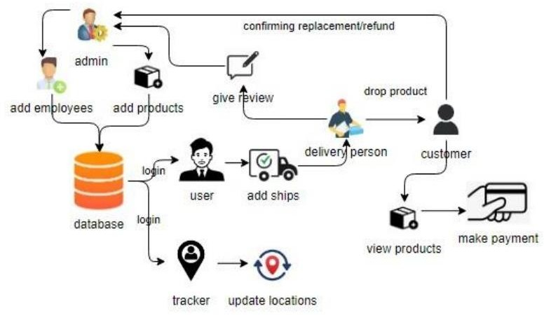

**Figure 4.1 Architecture Diagram**

# CHAPTER-5 OBJECTIVES

## Functional Requirements:

### Authentication of User:

Functional Aspect: This involves the specific functionality of authenticating a user. Input: User credentials (e.g., username, password).

Operation: Verify the provided credentials against stored data. Output: Grant access if credentials are valid; deny access otherwise.

### System Shutdown in Case of a Cyber-Attack:

Functional Aspect: This defines a specific action the system must take under a certain condition.

Input: Detection of a cyber-attack.

Operation: Initiate a system shutdown procedure. Output: System shuts down to prevent further damage.

### Verification Email for User Registration:

Functional Aspect: Involves a specific functionality related to user registration. Input: User registration details.

Operation: Send a verification email to the user.

Output: User receives a verification email for confirmation.

## Non-functional Requirements:

### Email Latency Requirement:

Non-functional Aspect: Specifies a constraint on the timing of a system response. Constraint: Emails must be sent within a latency of no greater than 12 hours.

### Processing Time Requirement:

Non-functional Aspect: Defines the time constraint for processing each request. Constraint: Each request processing should be completed within 10 seconds.

### Website Loading Time Requirement:

Non-functional Aspect: Focuses on the time it takes for the website to load.

Constraint: The site should load within 3 seconds, even when concurrent users exceed 10,000.

### Portability Requirement:

Non-functional Aspect (Portability): Concerns the system's ability to be moved to different environments.

Criterion: The system should be easily portable across different operating systems.

### Security Requirement:

Non-functional Aspect (Security): Emphasizes the measures in place to protect the system. Criterion: The system must implement encryption for sensitive data.

### Scalability Requirement:

Non-functional Aspect (Scalability): Addresses the system's ability to handle growing amounts of work.

Criterion: The system should scale gracefully to accommodate an increasing number of users.

### Maintainability Requirement:

Non-functional Aspect (Maintainability): Focuses on how easily the system can be maintained and updated.

Criterion: The system should be designed for easy maintenance, with clear documentation.

### Reliability Requirement:

Non-functional Aspect (Reliability): Deals with the system's ability to consistently perform. Criterion: The system should have a mean time between failures (MTBF) of a certain value.

### Flexibility Requirement:

Non-functional Aspect (Flexibility): Relates to how easily the system can adapt to changes. Criterion: The system should support easy integration with third-party services.

### Reusability Requirement:

Non-functional Aspect (Reusability): Addresses the potential for components or code to be reused.

Criterion: Code modules should be designed for reusability in future projects.

In summary, functional requirements focus on what the system does, while non-functional requirements focus on how well the system does it. Both types are crucial for ensuring a successful software project by meeting user needs and specifying the qualities that the system must possess.

# CHAPTER-6

**SYSTEM DESIGN & IMPLEMENTATION**

### Hardware Requirements:

* Processor - I3/Intel Processor
* Hard Disk - 160GB
* Key Board - Standard Windows Keyboard
* Mouse - Two or Three Button Mouse
* Monitor - SVGA
* RAM - 8GB

### Software Requirements:

* Operating System : Windows 7/8/10
* Server-side Script : JavaScript
* Programming Language : Python

# SYSTEM DESIGN

### Input Design:

In an information system, input is the raw data that is processed to produce output. During the input design, the developers must consider the input devices such as PC, MICR, OMR, etc. Therefore, the quality of system input determines the quality of system output. Well-designed input forms and screens have following properties −

* It should serve specific purpose effectively such as storing, recording, and retrieving the information.
* It ensures proper completion with accuracy.
* It should be easy to fill and straightforward.
* It should focus on user’s attention, consistency, and simplicity.
* All these objectives are obtained using the knowledge of basic design principles regarding
* What are the inputs needed for the system?
* How end users respond to different elements of forms and screens.

### Objectives for Input Design:

The objectives of input design are −

* To design data entry and input procedures
* To reduce input volume
* To design source documents for data capture or devise other data capture methods
* To design input data records, data entry screens, user interface screens, etc.
* To use validation checks and develop effective input controls.

### Output Design:

The design of output is the most important task of any system. During output design, developers identify the type of outputs needed, and consider the necessary output controls and prototype report layouts.

### Objectives of Output Design:

The objectives of output design are:

* To develop output design that serves the intended purpose and eliminates the production of unwanted output.
* To develop the output design that meets the end user’s requirements.
* To deliver the appropriate quantity of output.
* To form the output in appropriate format and direct it to the right person.
* To make the output available on time for making good decisions

# IMPLEMENTATION

## Modules:

In this application involved five characters to implement this process they are admin, User, Tracker, Delivery person and customer.

### ADMIN:

Operation – Login: The admin will login the page to enter the project. Operation – Add: Admin will add users, tracker, delivery person and products.

Operation – View dash board: Admin can view all ships and orders placed by customers. View review: admin will view the review of received products (damaged).

Operation – Response status: In this section admin can ask the customer for refund or replacement of damaged product.

Operation – Logout: The admin will logout once after users’ confirmation.

### USER:

Operation – Login: User can login with valid credentials. Operation – Add ships: User will add all ships.

Operation – Logout: The user will logout after adding ships.

### TRACKER:

Operation – Login: Tracker will login with valid credentials provided by admin.

Operation – Update status: After shipment with the help of tracking data tracker will update

the milestones of shipment has passed from the starting point to the destination and where a freight shipment or another delivery is currently located.

Operation – Logout: The tracker will logout after updating.

### CUSTOMER:

Operation – Register: Customer should register with their personal details such as name, email, password, phone number, address.

Operation – Login: Customer must register with valid credentials (email, password). Operation – View Dashboard: Customer can view all ships from dashboard.

Operation – View products: In this section customer can view all products.

Operation – Place order: After gone through the all products customer can place order with their selected product and will make payment.

Operation – Tracking: After order placement, customer can track their product movement location.

Operation – Status: After receiving the ordered product he/she will check that product if it is damaged him will inform to delivery person.

Operation – Confirmation: Here customer will confirm about refund or replacement of his/her damaged product.

### DELIVERY PERSON:

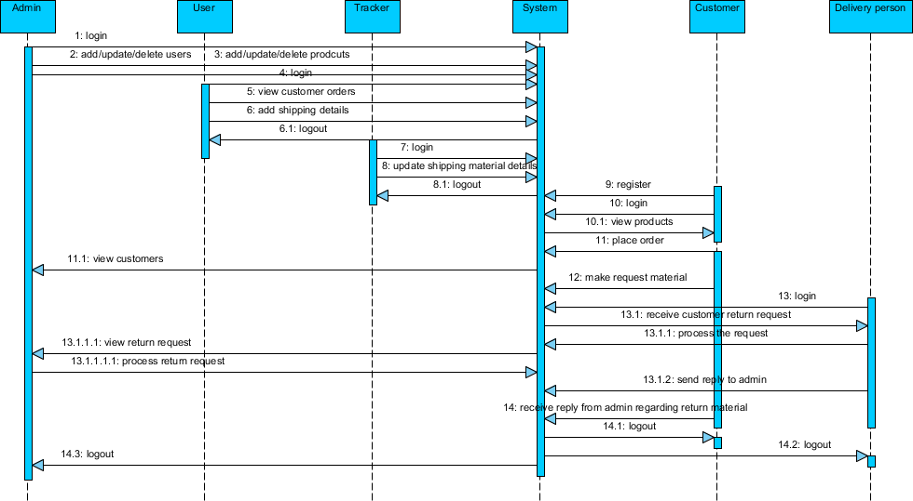Operation – Login: Tracker will login with valid credentials provided by admin. Operation – Give review: After dropping product based on customer review delivery person can send review to admin about received damaged product.

***Figure 6.1Sequence Diagram***

# CHAPTER-7

**TIMELINE FOR EXECUTION OF PROJECT (GANTT CHART)**

|  |  |  |  |  |
| --- | --- | --- | --- | --- |
| S.NO | Review | Start Date | End Date | Duration |
| 1 | Review 0 | 09-Oct-23 | 13-Oct-23 | 5 |
| 2 | Review 1 | 06-Nov-23 | 10-Nov-23 | 5 |
| 3 | Review 2 | 27-Nov-23 | 30-Nov-23 | 4 |
| 4 | Review 3 | 26-Dec-23 | 30-Dec-23 | 4 |
| 5 | Final Viva-Voce | 08-Jan-24 | 12-Jan-24 | 5 |

**Figure 7.1 TimeLine for Execution**

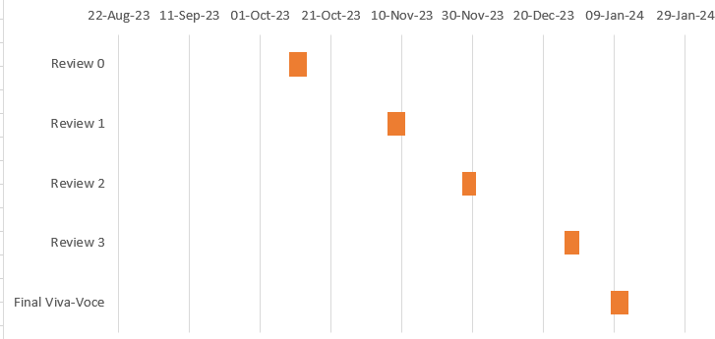

**Figure 7.2 Gantt Chart**

# OUTCOMES

Implementing an automated system for processing material returns from customers provides a myriad of advantages that significantly enhance operational efficiency and customer satisfaction. One primary benefit lies in the substantial increase in processing speed and efficiency, achieved by minimizing manual intervention and allowing the system to handle large volumes of returns simultaneously. The utilization of tracking mechanisms, such as barcodes or RFID tags, ensures precise item identification, mitigating human errors and contributing to a seamless and error-free customer experience. Moreover, the adoption of automated return systems leads to substantial cost savings by reducing reliance on manual labor, positively impacting the bottom line while streamlining the return process for increased cost-effectiveness.

In addition to operational benefits, automated systems contribute to a positive customer experience, fostering satisfaction and loyalty through quick and hassle-free returns. The real- time data sharing and updates facilitated by these systems enhance communication channels between customers, support teams, and stakeholders, promoting transparency and responsiveness. Beyond customer-centric advantages, the implementation of automated systems aligns with environmental sustainability goals by aiding in proper item handling and waste minimization, thereby supporting eco-friendly practices and contributing to a positive brand image. While the benefits are compelling, careful design and maintenance are crucial to address potential challenges and ensure a positive and enduring impact on overall business operations.

# CHAPTER-9 RESULTS AND DISCUSSIONS

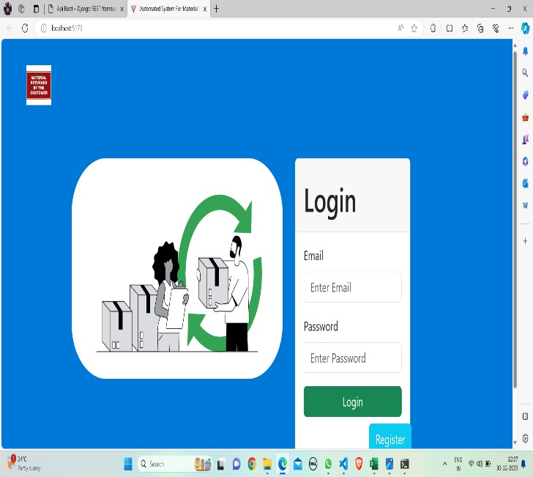

**Figure 9.1 Login Page**

The provided diagram illustrates information pertaining to login credentials and the registration process for new individuals.

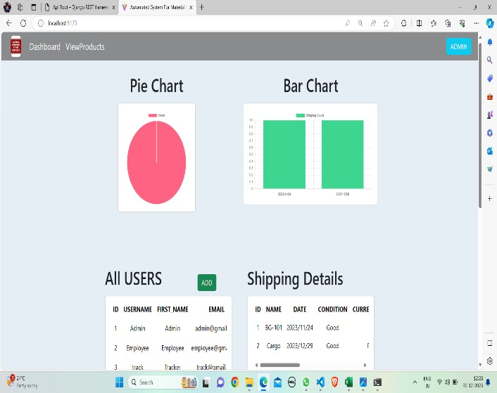

**Figure 9.2 Admin Page**

The diagram above delineates the administrative responsibilities, encompassing tasks such as reviewing user information, examining product details, adding new products, and assessing the conditions of each product.

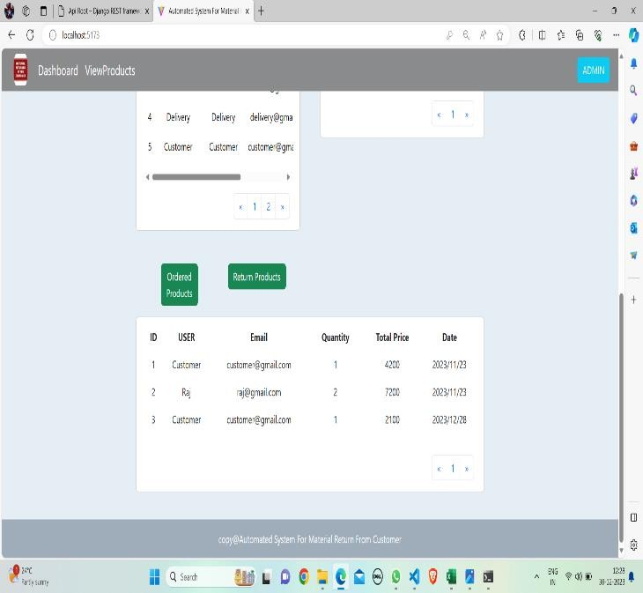

**Figure 9.2.1 Admin Page**

The diagram above displays information on both ordered products and returned products within the administrative interface.

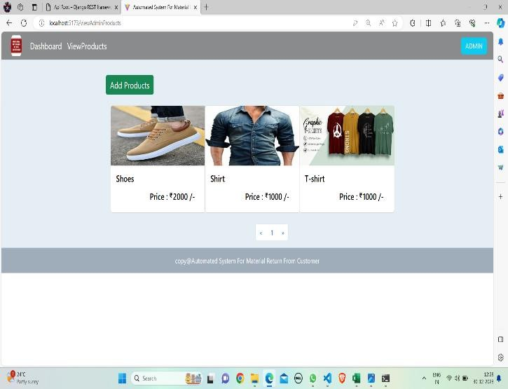

**Figure 9.2.2 Admin Page**

The above diagram depicts the process of adding products on the admin page, along with the ability to review and verify the presence of existing products.

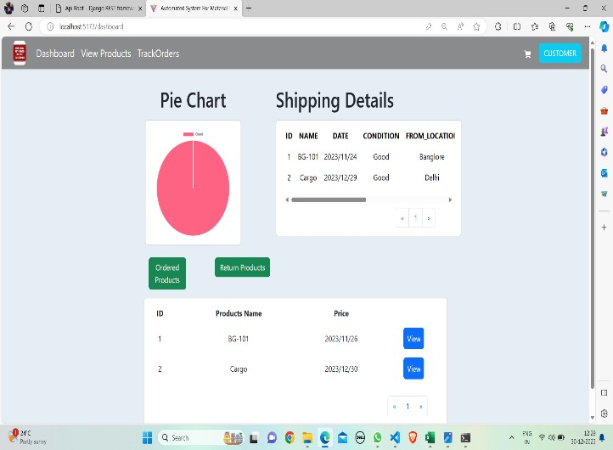

**Figure 9.3 Customer Page**

The provided diagram utilizes a pie chart to convey product details, encompassing information on shipping details as well as products that have been ordered and returned by customers.

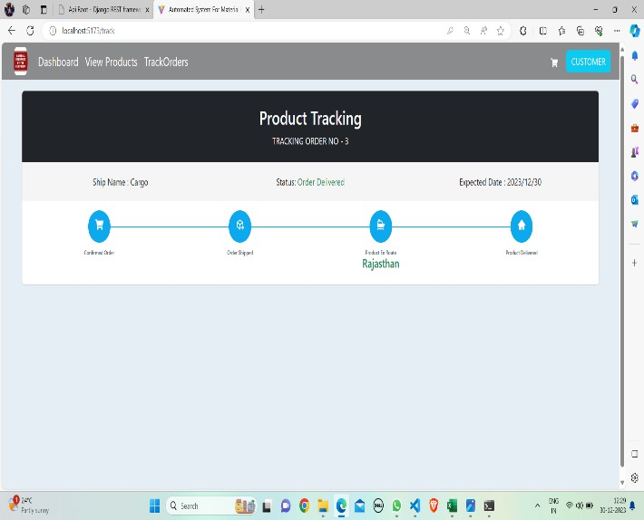

**Figure 9.3.1 Tracking Page (Customer)**

The diagram above provides insights into the tracking of products through the use of specific product IDs.

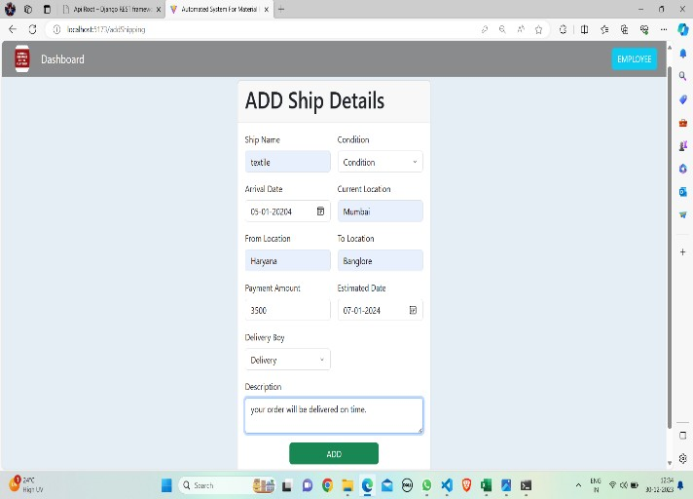

**Figure 9.4 Employee Page**

The diagram above outlines the process of entering shipping details by an employee, with the information subsequently appearing on the ordered products page.

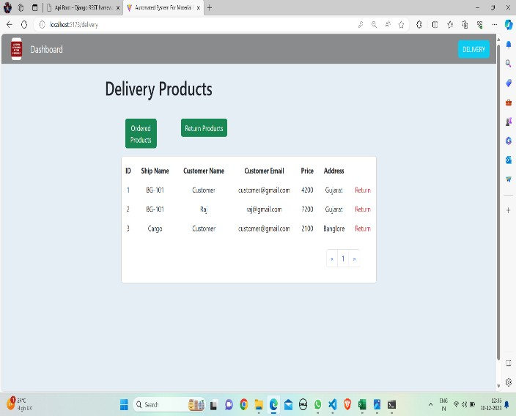

**Figure 9.4 Delivery Page**

The diagram above provides information on both ordered products and returned products that are delivered to customers by a delivery person, as depicted in the delivery page.

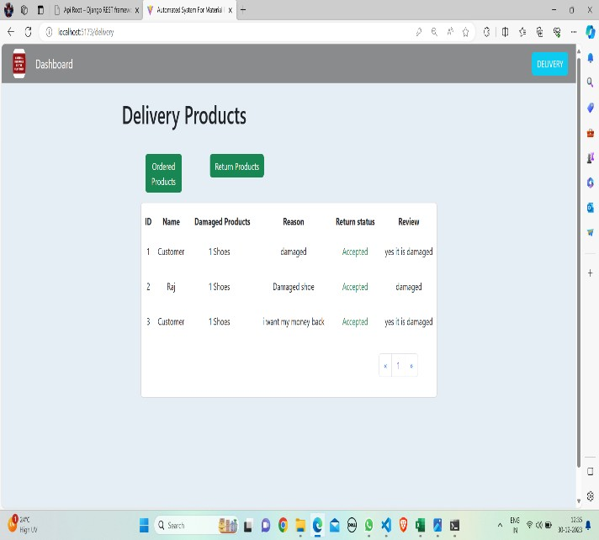

**Figure 9.4.1 Delivery Page**

The diagram above conveys the return status of each product individually, providing specific information about the status of product returns.

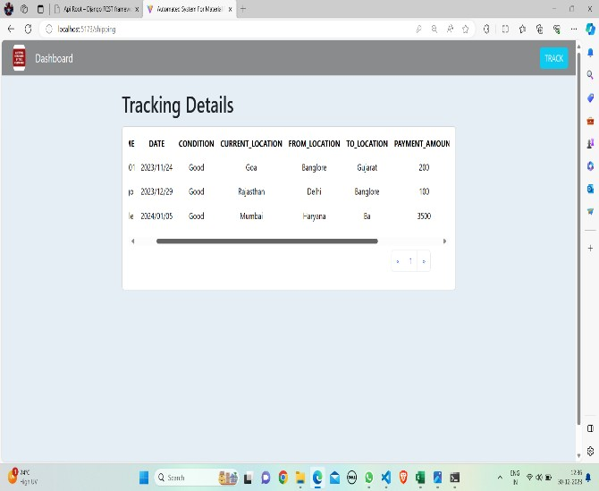

**Figure 9.5 Tracking Page**

The diagram above outlines the tracking system for products that have been ordered by customers, providing a mechanism to monitor the status and location of these items.

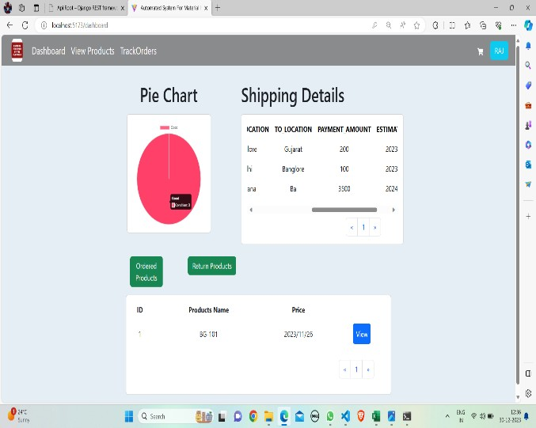

**Figure 9.5 Customer (Raj) Page**

The diagram above illustrates product details specifically associated with a particular customer (raj), offering insights into the items ordered, their specifications, and related information for that specific customer.

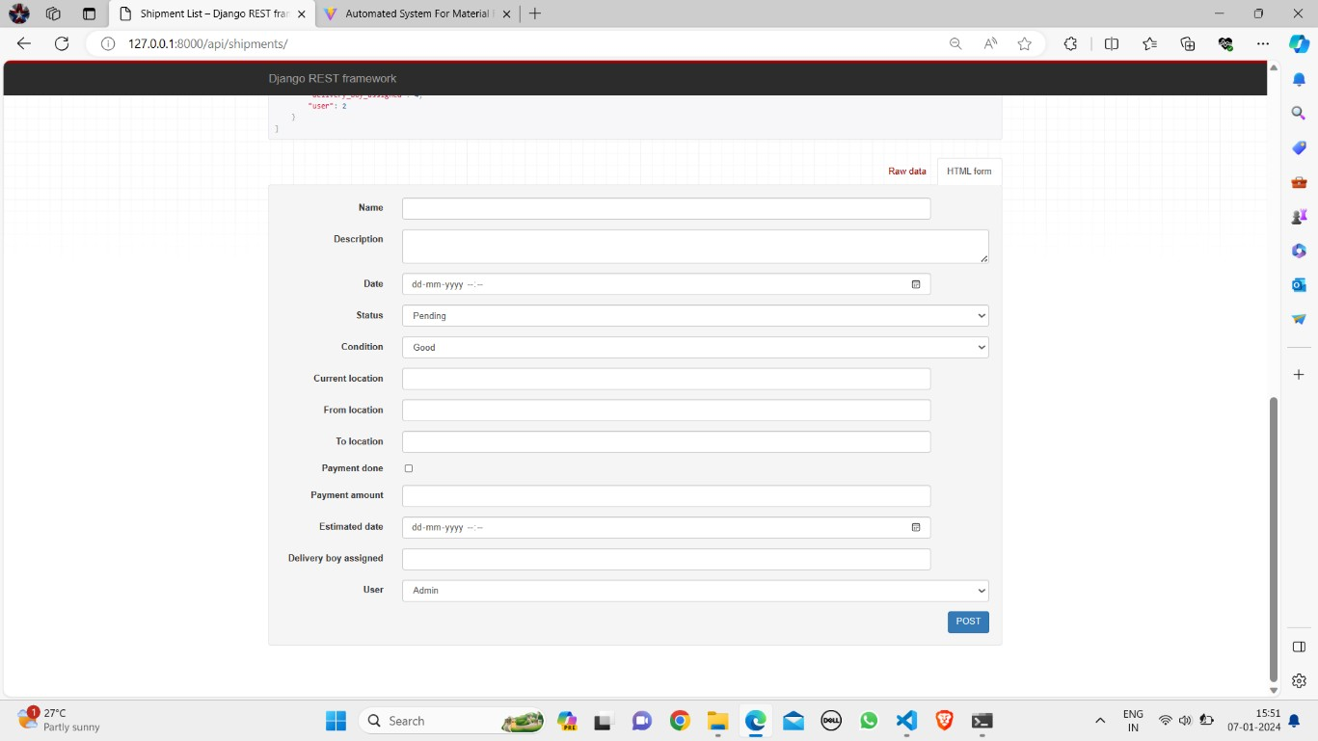

**Figure 9.6 Shipping Details (Backend)**

The diagram above represents the process of entering shipping details for a specific product, involving the completion of information such as destination address, delivery method, and other pertinent details to facilitate the shipping process.

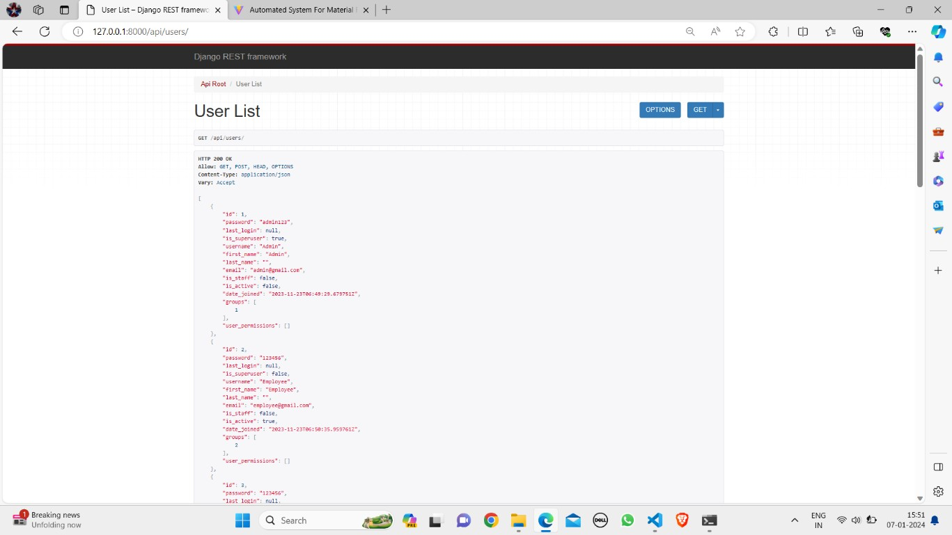

**Figure 9.7 Users List (Backend)**

The diagram above provides information about the registered users, offering insights into the user base and their respective registration details.

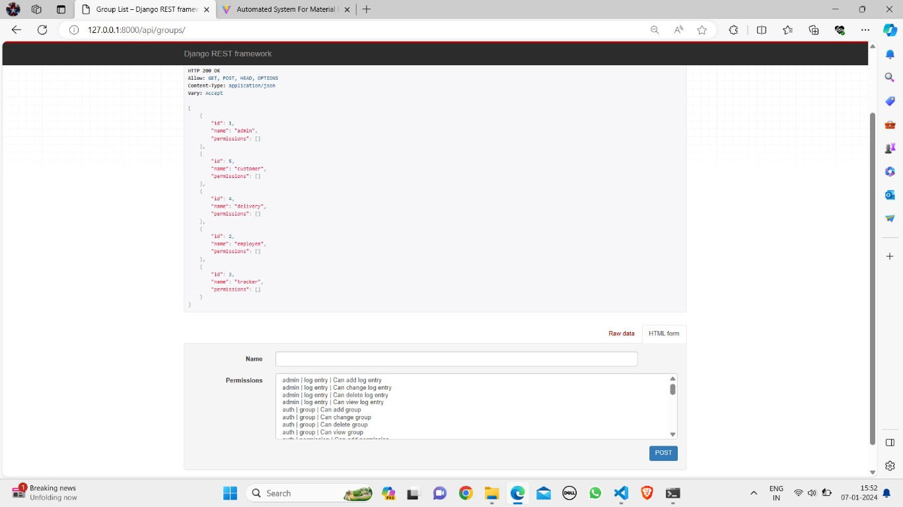

**Figure 9.8 Groups (Backend)**

The diagram above depicts information about both existing registered members and newly registered members, highlighting the composition of the user base.

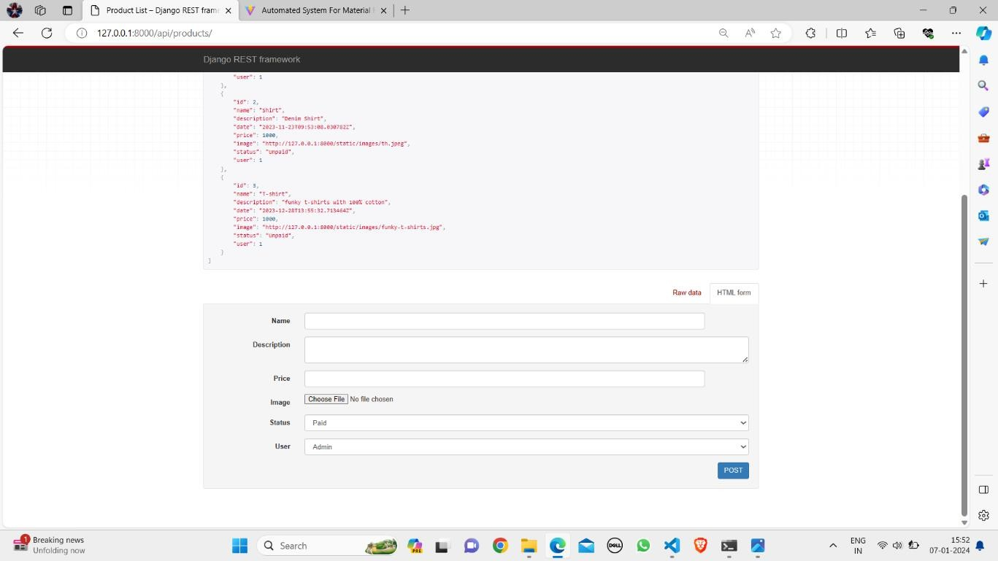

**Figure 9.9 Products (Backend)**

The above diagram showcases information concerning both pre-existing product details that have been stored and newly added products, presenting a comprehensive view of the product inventory.

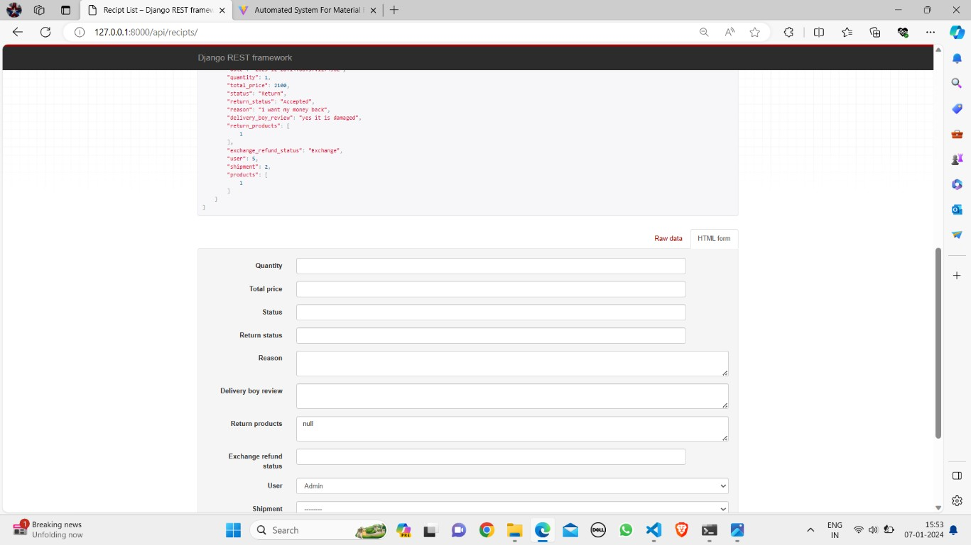

**Figure 9.10 Receipts (Backend)**

The diagram above provides details about the receipts associated with each individual product, offering insights into the transaction records or documentation related to the products.

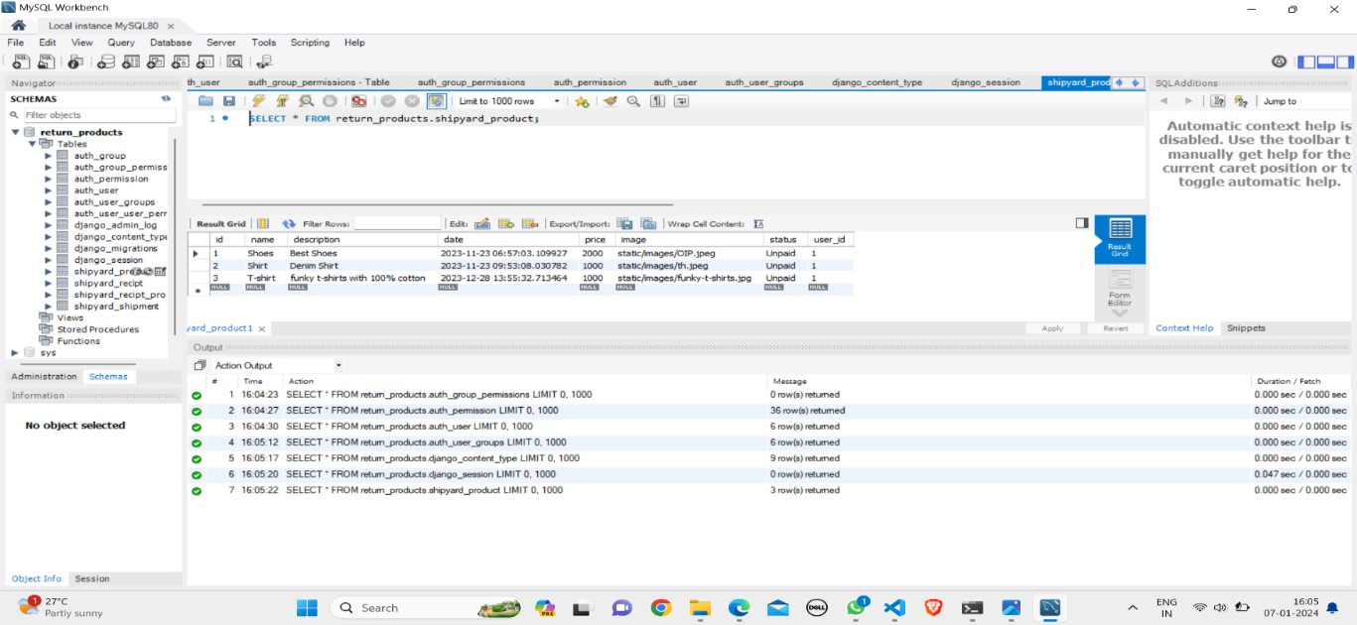

**Figure 9.11 Products (Database)**

The above diagram illustrates the process of storing products in databases, specifically those added by employees. It provides a visual representation of how product information is organized and maintained within the database.

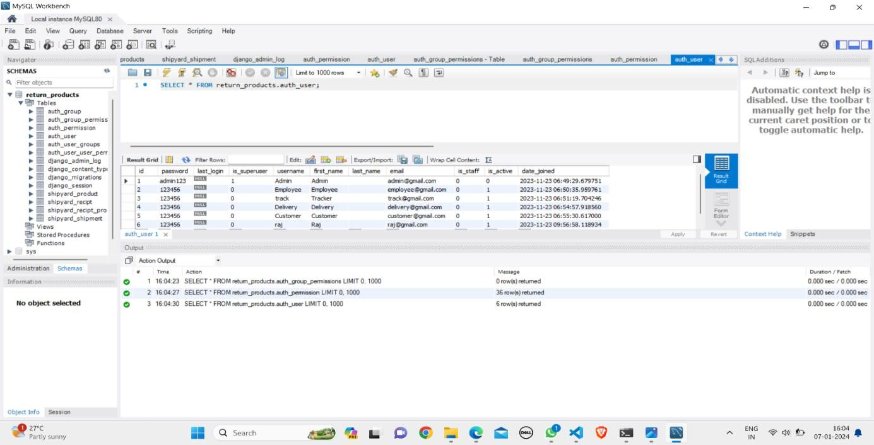

**Figure 9.12 Users (Database)**

The above diagram visually represents information about users who have already been added, and it demonstrates the automatic reflection of new members when added to the database. It highlights the dynamic nature of the database as it updates to include newly added members.

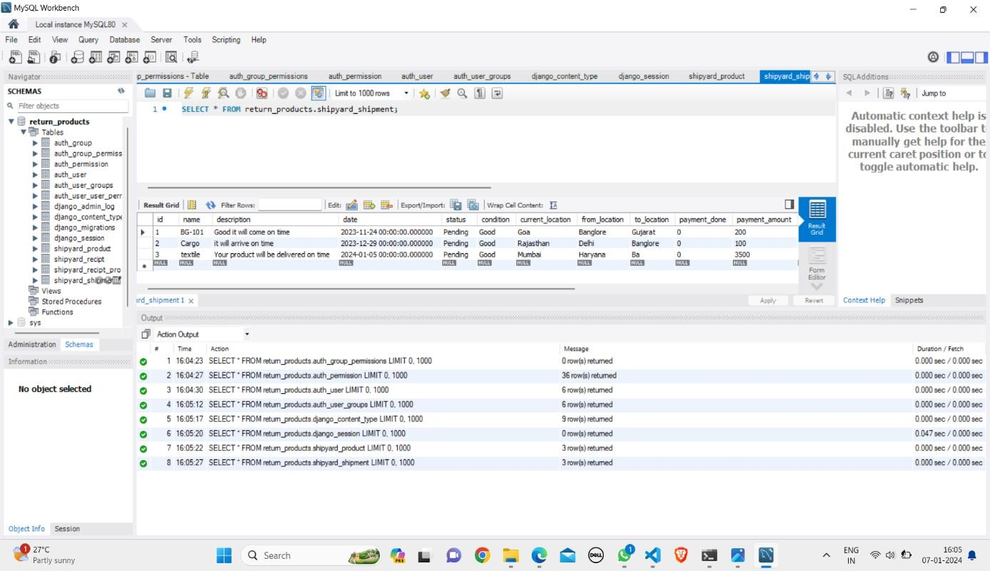

**Figure 9.13 Shipments (Database)**

The above diagram illustrates shipment details added by the customer through the employee page. It provides a visual representation of how customers input information related to shipments using the employee interface.

# CHAPTER-10 CONCLUSION

The essential development of a robust system aimed at facilitating the return process for damaged products is pivotal in elevating customer satisfaction and preserving the reputation of e-commerce enterprises. This system, strategically designed to tackle challenges such as miscommunication, delays, and a lack of transparency, possesses the capacity to efficiently streamline the return process, providing customers with an enhanced and stress-free experience. The incorporation of user management functionalities for administrators and order tracking capabilities for customers further enhances the system's value, promoting transparency and accountability.

Through the adoption of this proposed solution, businesses can achieve more than just operational efficiency; they have the potential to significantly enhance customer trust, alleviate dissatisfaction, and ultimately foster lasting relationships with their customer base. This, in turn, establishes the groundwork for sustainable growth and success in the fiercely competitive landscape of the online market. The comprehensive nature of this system not only addresses immediate concerns but also positions businesses for long-term success by prioritizing customer-centricity and building trust.

# REFERENCES

* + 1. [**https://jtec.utem.edu.my/jtec/article/view/3595/2488**](https://jtec.utem.edu.my/jtec/article/view/3595/2488) **2.https://citeseerx.ist.psu.edu/document?repid=rep1&type=pdf&doi=3c025f2b67f45 a24834b8bb3d4bb4538e3b541db**

**3.**[**https://cyberleninka.ru/article/n/the-improvement-and-automation-of-the-**](https://cyberleninka.ru/article/n/the-improvement-and-automation-of-the-processes-of-the-products-reception-and-assembly-in-the-trade-warehouse-complex)[**processes-of-the-products-reception-and-assembly-in-the-trade-warehouse-complex**](https://cyberleninka.ru/article/n/the-improvement-and-automation-of-the-processes-of-the-products-reception-and-assembly-in-the-trade-warehouse-complex) **4. http**[**s://www**](http://www.mdpi.com/2071-1050/14/15/9518)**.mdp**[**i.com/2071-1050/14/15/9518**](http://www.mdpi.com/2071-1050/14/15/9518)

1. **SMART: Identification of relevant information about train classification process and marshalling yard sorting methods, Report for Deliverable D4.1. of EU-SMART-project underGA-No.730836, 2017.Available at:** [**http://smartrailautomationproject.net/index.php/results/deliverables**](http://smartrailautomationproject.net/index.php/results/deliverables)
2. **SMART: Overall framework architecture and list of requirements for real-time marshalling yard management system, Report for Deliverable D4.2. of EU-SMART- project under GA-No. 730836, 2017. Available at:** [**http://smartrailautomation-**](http://smartrailautomation-/) **project.net/index.php/results/deliverables**
3. **ARCC: Description of automation/optimization requirements and capabilities of decision making process in Marshalling yards and Terminals, Report for Deliverable D2.1. of EUARCC-project under Contract No. H2020 – 730813/MC S2RCFM-IP5- 02-2015, 2017**

### 8.J.Adlbrecht, B.Hüttler, N. Ilo, M.Gronalt. Train routing in shunting yards using Answer Set Programming. Expert Systems with Applications, Volume 42, Issue 21, Pages 7292- 7302, Elsevier, 2015.

**9.H. Djellab, C. Mocquillon. An efficient heuristic method for the hump yard management problem. Proceedings of 12th World Conference on Transport Research, Lisbon, Portugal, 2010.**

### 10.S. Gestrelius, F. Dahms, and M. Bohlin. Optimisation of simultaneous train formation and car sorting at marshalling yards. In Proceedings of the 5th International Seminar on Railway Operations Modelling and Analysis (RailCopenhagen), Copenhagen, Denmark, 2013.

**ADMIN:**

# APPENDIX-A PSUEDOCODE

Operation – Login: The admin will login the page to enter the project. Operation – Add: Admin will add users, tracker, delivery person and products.

Operation – View dash board: Admin can view all ships and orders placed by customers. View review: admin will view the review of received products (damaged).

Operation – Response status: In this section admin can ask the customer for refund or replacement of damaged product.

Operation – Logout: The admin will logout once after users’ confirmation.

### USER:

Operation – Login: User can login with valid credentials. Operation – Add ships: User will add all ships.

Operation – Logout: The user will logout after adding ships.

### TRACKER:

Operation – Login: Tracker will login with valid credentials provided by admin.

Operation – Update status: After shipment with the help of tracking data tracker will update the milestones of shipment has passed from the starting point to the destination and where a freight shipment or another delivery is currently located.

Operation – Logout: The tracker will logout after updating.

### CUSTOMER:

Operation – Register: Customer should register with their personal details such as name, email, password, phone number, address.

Operation – Login: Customer must register with valid credentials (email, password). Operation – View Dashboard: Customer can view all ships from dashboard.

Operation – View products: In this section customer can view all products.

Operation – Place order: After gone through the all products customer can place order with their selected product and will make payment.

Operation – Tracking: After order placement, customer can track their product movement location.

Operation – Status: After receiving the ordered product he/she will check that product if it is damaged him will inform to delivery person.

Operation – Confirmation: Here customer will confirm about refund or replacement of his/her damaged product.

### DELIVERY PERSON:

Operation – Login: Tracker will login with valid credentials provided by admin. Operation – Give review: After dropping product based on customer review delivery person can send review to admin about received damaged product.

# APPENDIX-B SCREENSHOTS



**Figure B.1 Login Page**

The provided diagram illustrates information pertaining to login credentials and the registration process for new individuals.



**Figure B.2 Admin Page**

The diagram above displays information on both ordered products and returned products within the administrative interface.



**Figure B.3 Employee Page**

The diagram above outlines the process of entering shipping details by an employee, with the information subsequently appearing on the ordered products page.



**Figure B.4 Delivery Page**

The diagram above conveys the return status of each product individually, providing specific information about the status of product returns.



**Figure B.5 Products (Backend)**

The above diagram showcases information concerning both pre-existing product details that have been stored and newly added products, presenting a comprehensive view of the product inventory.

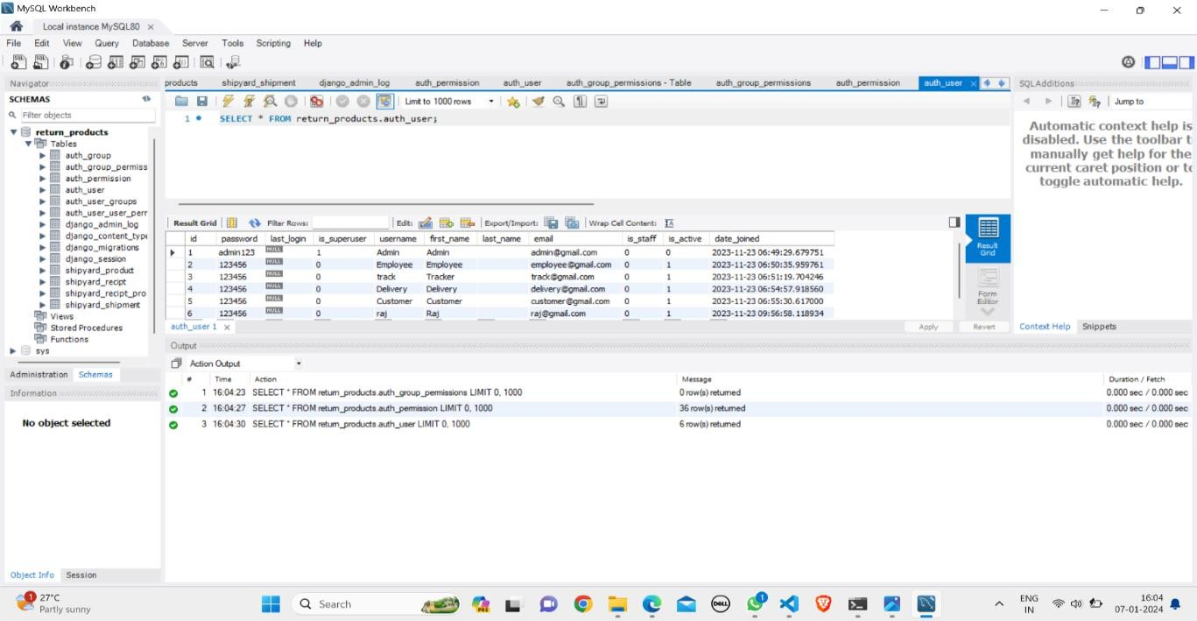

**Figure B.6 Products (Database)**

The above diagram illustrates the process of storing products in databases, specifically those added by employees. It provides a visual representation of how product information is organized and maintained within the database.